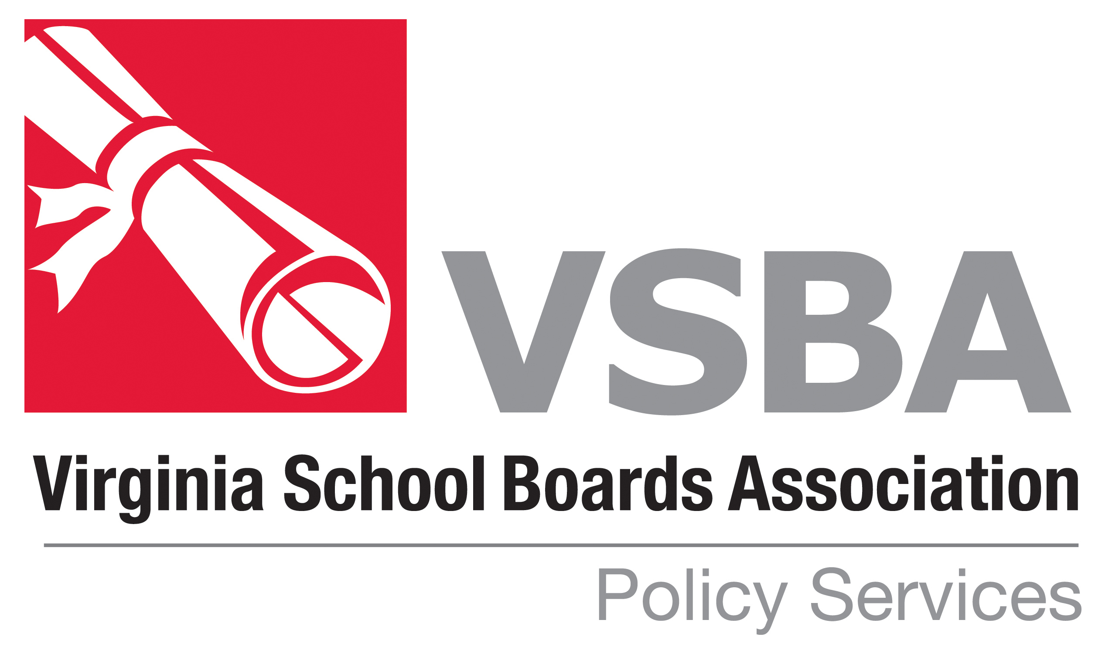
VSBA POLICY UPDATE-February 2021

WHAT THE UPDATE CONTAINS . . .

The most recent revisions to the VSBA Policy Manual have been posted on the VSBA website (vsba.org.) The revisions are provided in both final and strike-through format. The strike-through format shows each change made to the policies (the changes are designated by underlining new language and striking through deleted language). The Policy Update will remain on the website for approximately one year. After that the policies will be incorporated into the VSBA Policy Manual available on the website. The revisions are based on changes in law and regulations. In addition, a few policies are revised for editorial reasons or to correct technical errors. All of the revisions have been reviewed for legality.

This document is also posted with the updated policies.

HOW TO USE THE UPDATE . . .

A brief explanation is given for each revision later in this document. Each revision should be examined and then the School Board should decide whether to adopt the revised policies. Some policies require local input before adoption. Be sure to add information where indicated.

The VSBA copyright and the date the policies are revised appear on all VSBA policies. If VSBA policies are changed in any way, the copyright reference should be deleted from the policy. VSBA policies adopted verbatim should retain the VSBA copyright symbol.

Please contact the Policy Services Department at VSBA if you have any questions, (434) 295-8722.

Explanation of Revisions – February 2021 Policy Update

Policy Code Revision

BBA School Board Powers and Duties
Cross References updated.

BBBA Qualifications of School Board Members
Policy updated.

BDDC Agenda Preparation and Dissemination
Policy updated.

BDDH/KD Public Participation at School Board Meetings
Policy updated.

DIA Reporting Per Pupil Costs
Policy and Legal Reference updated.

DJF Purchasing Procedures
Policy and Cross References updated to reflect amendment of Va. Code § 22.1-296.1 by HB 392.

GBG Staff Participation in Political Activities
Policy updated.

GBL Personnel Records
Policy and Cross References updated.

GCBA Staff Salary Schedules
Policy and Legal References updated.

GCBC Staff Benefits
Policy title and text updated.

GCBE Family and Medical Leave
Policy, Legal References, and Attachments updated.

GCPA Reduction in Professional Staff Work Force
Policy updated.

Note: policy requires superintendent to create guidelines to be approved by the school board.

GCQA Nonschool Employment by Staff Members
Policy and Cross References updated.

GCQAB Tutoring for Pay
Legal References and Cross References updated.

GDN Evaluation of Support Staff
Policy, Legal References and Cross Reference updated.

IEA Pledge of Allegiance
Policy and Cross References updated.

IGAH Family Life Education
(Optional) Policy updated to reflect amendment of Va. Code § 22.1-207.2 by HB 1394; new requirements are effective for 2021-2022 school year.

IGBH Alternative School Programs
Policy updated.

IICA Field Trips
Policy, Legal References and Cross Reference updated.

IICB/IICC Community Resource Persons/School Volunteers
Policy and Cross References updated.

INB Teaching About Controversial Issues
Policy and Cross References updated.

JFCE Gang Activity or Association
Policy, Legal References and Cross References updated.

JFCL Notification Regarding Prosecution of Juveniles as Adults
Policy updated.

JGD/JGE-R Student Suspension/Expulsion
Regulation deleted.

JHH Suicide Prevention
Policy updated.

Note: policy requires superintendent to create procedures for the notification of parents in accordance with BOE Guidelines.

JL Fund Raising and Solicitation
Policy and Cross References updated.

KBC Media Relations
Policy and Cross Reference updated.

KC Community Involvement in Decision Making
Policy and Legal References updated.

KD/BDDH Public Participation at School Board Meetings
Policy updated.

KGB Public Conduct on School Property
Policy, Legal References, and Cross References updated.

KK School Visitors
Policy and Cross References updated.

KKA Service Animals in Public Schools
Policy and Cross References updated.

KN Sex Offender and Crimes against Minors Registry Information
Title and text of policy updated to reflect amendment of Va. Code §§ 9.1-902, 18.2-370.5 by SB 579.

KNA Violent Sex Offenders on School Property
Policy deleted. Substance of policy incorporated into Policy KN Sex Offender Registry Information.

KNAJ Relations with Law Enforcement Authorities
Policy and Cross References updated.

KP Parental Rights and Responsibilities
Policy and Cross References updated.

LB Relations with Private Schools
Policy updated.

LEA Student Teachers
Policy deleted.

