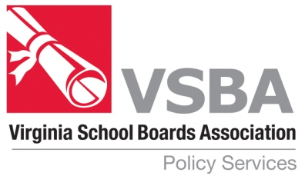

Policies Reviewed but not Revised
February 2021

BBBC Option 1 Board Member Oath of Office
BBBC Option 2 Board Member Oath of Office
CA Administration Goals
GBO Virginia Retirement System
GCBD Staff Leaves and Absences
GD Support Staff
GDB Support Staff Employment Status
GDG Support Staff Probationary Period
IIAA Textbook Selection, Adoption and Purchase
IHB Class Size
JB-F Report of Discrimination
JGA Corporal Punishment
KBA-F2 Record of Inspection and/or Delivery or Copies

