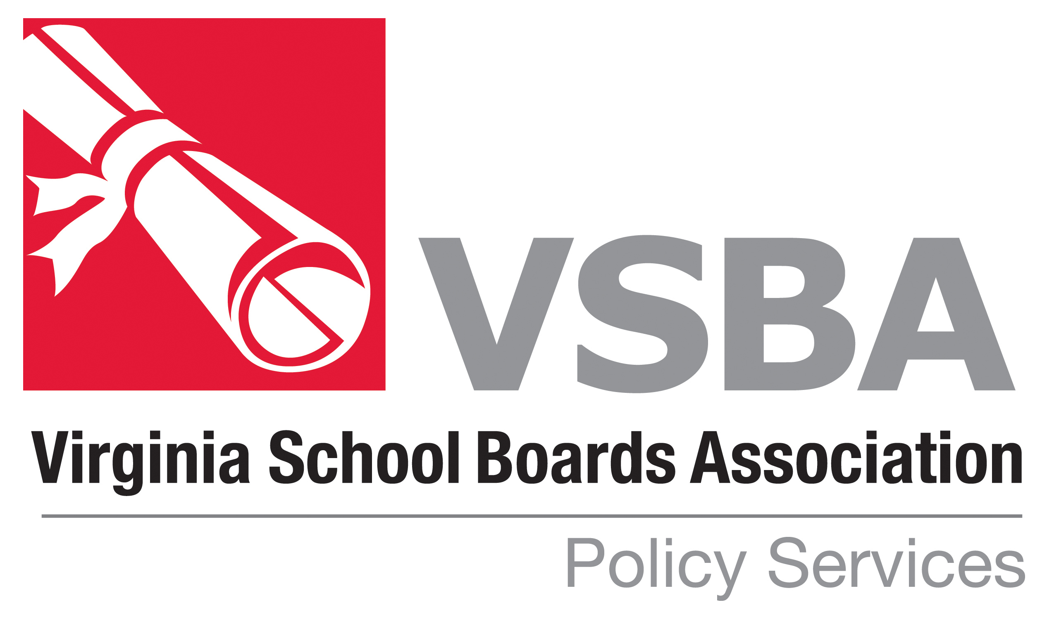
VSBA POLICY UPDATE-August 2021

WHAT THE UPDATE CONTAINS . . .

The most recent revisions to the VSBA Policy Manual have been posted on the VSBA website (vsba.org.) The revisions are provided in both final and strike-through format. The strike-through format shows each change made to the policies (the changes are designated by underlining new language and striking through deleted language). The Policy Update will remain on the website for approximately one year. After that the policies will be incorporated into the VSBA Policy Manual available on the website. The revisions are based on changes in law and regulations. In addition, a few policies are revised for editorial reasons or to correct technical errors. All of the revisions have been reviewed for legality.

This document is also posted with the updated policies.

HOW TO USE THE UPDATE . . .

A brief explanation is given for each revision later in this document. Each revision should be examined and then the School Board should decide whether to adopt the revised policies. Some policies require local input before adoption. Be sure to add information where indicated.

The VSBA copyright and the date the policies are revised appear on all VSBA policies. If VSBA policies are changed in any way, the copyright reference should be deleted from the policy. VSBA policies adopted verbatim should retain the VSBA copyright symbol.

Please contact the Policy Services Department at VSBA if you have any questions, (434) 295-8722.

Explanation of Revisions – August 2021 Policy Update

Policy Code Revision

AD Educational Philosophy
Legal Reference updated to correct typographical error.

GAA Staff Time Schedules
Policy updated to reflect adoption of HB 7001 (the budget bill) which became effective on August 10, 2021.
Cross References updated.

